#include<stdio.h>

int main()

{

    int arr[50],pos,i,n,value;

    printf("Enter number of elements in an array\n");

    scanf("%d",&n);

    printf("Enter %d element\n",n);

    for(i=0;i<n;i++)

    scanf("%d",&arr[i]);

    printf("Please enter the location where you want to enter new element\n");

    scanf("%d",&pos);

    printf("enter the value\n");

    scanf("%d",&value);

    for(i=n-1;i>=pos-1;i--)

    arr[i+1]=arr[i];

    arr[pos-1]=value;

    printf("Resultant array is\n");

    for(i=0;i<=n;i++)

    printf("%d\n",arr[i]);

    return 0;

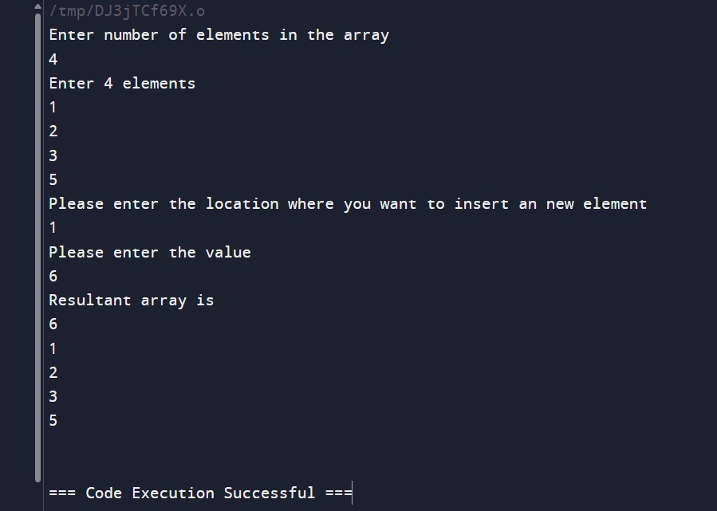

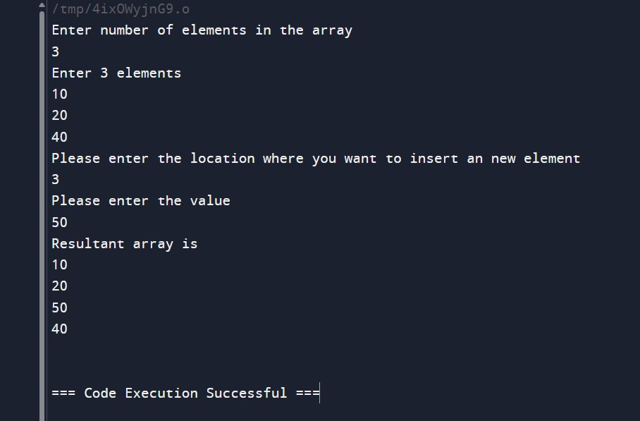

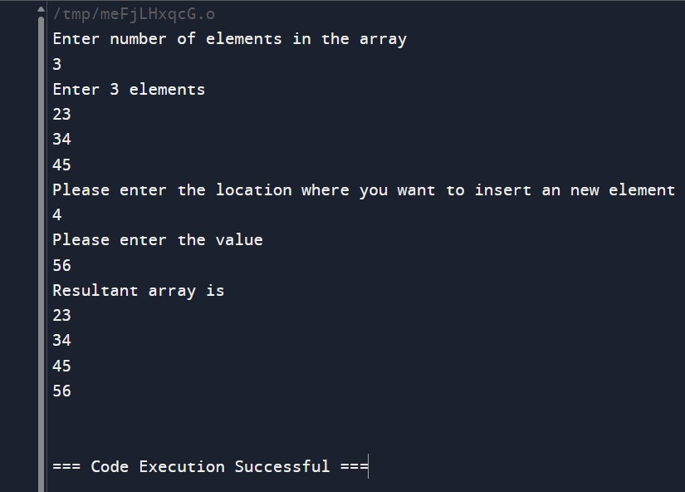

#include<stdio.h>

int main()

{

    int arr[100],pos,i,n;

    printf("Enter number of elements in array\n");

    scanf("%d",&n);

    printf("Enter %d elements\n",n);

    for(i=0;i<n;i++)

    scanf("%d",&arr[i]);

    printf("Enter the location where you wish to delete element\n");

    scanf("%d",&pos);

    if(pos>=n+1)

    printf("Deletion not possible\n");

    else{

        for(i=pos-1;i<n-1;i++)

        arr[i]=arr[i+1];

        printf("Resultant array is\n");

        for(i=0;i<n-1;i++)

        printf("%d\n",arr[i]);

    }

    return 0;

}

